

DATE:

PROPOSAL FOR OUR MODEL:

7100-65-OHA

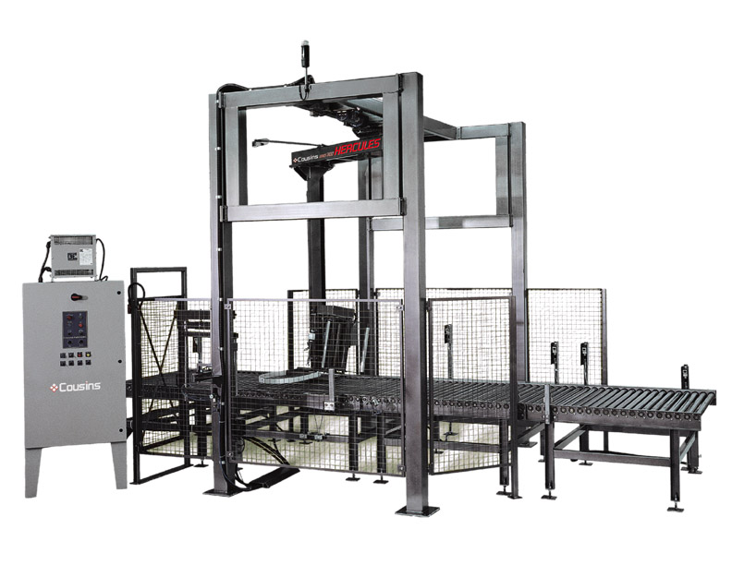
Shown with optional free-standing control panel

Cousins Packaging Inc. 105 Claireport Crescent Etobicoke, Ontario, Canada M9W 6P7
1-888-209-4344 or 416-743-1341 fax 416-743-1831

www.cousinspackaging.com


MODEL 7100-65-OHA “HERCULES” HEAVY DUTY

OVERHEAD CONVEYORIZED AUTOMATIC

STRETCH WRAP SYSTEM

GENERAL SPECIFICATIONS

PRODUCTION SPEED:

- 1-65 loads per hour
NOTE: Process rates will vary with load size, number of wraps & conveyor speed

LOAD CAPACITY:

- Maximum load weight: 4,000# dynamic – 12,000# static
- Maximum load size: 56” W x 56” L (79” max. load diagonal) x 80” H (plus up to 4” top overlap)
- Minimum load size: 30” W x 30” L x 24” H

ROTARY ARM:

- 20” diameter ring bearing support system
- ANSI # 60 direct chain drive c/w chain tensioner
- 1-22 RPM rotational speed c/w soft start acceleration
- Final revolution deceleration and positive stop alignment
- 1 HP DC variable speed motor

FILM CARRIAGE ELEVATOR:

- 3/4 HP DC variable speed motor
- ANSI # 50 direct chain drive c/w shock dampeners
- Maintenance free 12 point carriage guidance system

FILM DELIVERY SYSTEM:

- NEW Super Rapid Thread II ™ 20” capacity pre-stretch film carriage
- Special Film Threading Device – Uniquely orientates the sticky side of the film against the pre-stretch rollers and the inside of the load.
- 1/2 HP DC variable speed motor
- Fully electronic dynamic dancer corner compensation
- 33% to 313% fixed stretch capability
- Pre-stretch ratio variable using easy sprocket change
- Rapid Thread ™ Safety Door with auto power cut-off switch
- Superior film-to-roller contact area
- Lifetime warranty on pre-stretch rollers

POWERED ROLLER CONVEYOR:

Basic system: 5ft infeed section, 12ft Process/wrap zone section and 5ft exit section

Each section includes:
- Chain driven live roller conveyor rated 4,000# per section
- 2-1/2” diameter 11 gauge rollers c/w 11/16” hex axles on 3” centers
- 54” effective roller width
- All rollers ANSI # 40 chain driven, roller to roller
- Conveyor speeds 30 to 60 FPM (specify required speed) with electronic soft start
POWERED ROLLER CONVEYOR (continued):

- Pass-line height – 18” from floor to top of rollers
- 3/4 HP AC variable speed reversible TEFC motors on infeed & outfeed conveyors
- 1 HP AC variable speed reversible TEFC motor on process conveyor
- Automatic load indexing and centering by photo-eye & PLC logic

CONTROL FEATURES:

- Allen-Bradley MicroLogix 1400 Programmable Logic Controller (PLC) with built-in EtherNet/IP communications
- HMI Touchscreen Operator Interface Panel
- Illuminated Power Start / Reset button
- Emergency Stop button
- Wrap Cycle Start (rewrap) button
- Manual controls provided for rotary arm jog, film carriage elevator lower/raise,
film clamp open/close and conveyors forward/reverse
- Wrap Bypass mode selector switch
- Separate film carriage elevator raise & lower speed controls
- Film tension (Force-to-Load) control
- Separate 1 to 12 revolution top & bottom wrap control
- Triple beam auto load height sensing photo-eye, detects dark or shiny loads
- Broken film/out of film detection c/w automatic machine reset and fault beacon light
- Rotary arm and film carriage elevator dynamic braking
- NEMA 12 control panel and junction boxes
- Dust tight slip ring assembly
- Non-proprietary UL/CSA approved components

AUTOMATION FEATURES:

- Pneumatically actuated film clamp mechanism
- Pneumatically actuated film tail cut/wiper arm mechanism
- Ni-chrome impulse hot wire film cut off c/w automatic periodic cleaning cycle

STRUCTURAL FEATURES:

- All structural steel construction
- Structural tube machine tower & frame
- Electro-static powder coated paint finish

SAFETY FEATURES:

- Personnel Safety – Rotary Arm Obstruction Emergency Stop Sensor
- Wire mesh safety barriers enclose the wrap zone to prevent personnel intrusion
- Operator Access Gates c/w Safety Interlock Switches disable machine operation when gate(s) opened
- Hard-wired emergency stop and operator access gate circuits with Category 3 dual channel safety relays

ELECTRICAL INPUT REQUIREMENT:

- 230 or 460 Volts 3 Phase 60 Hz 30 Amps (required voltage to be specified)

PNEUMATIC REQUIREMENT:

- 3 CFM @ 80 PSI clean dry pneumatic supply required
- Filter/regulator c/w gauge & lock-out valve provided
TYPICAL SYSTEM DIMENSIONS:

264” (L) x 167” (W) x 140” (H)
(Overall includes conveyor (L) and Control panel (W) – all dimensions approximate)

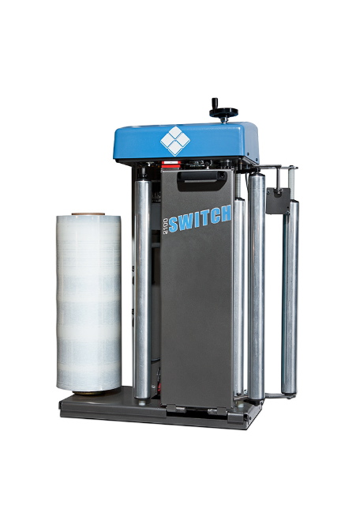
Performance Inspired Super Rapid Thread II film carriage

The Super Rapid Thread ll film carriage is patent pending and is
the most innovative carriage design to date. In the past, most
manufacturers decided to use easy thread safety doors for the
ease of film threading and safety. This reduced the “film-to-pre-
stretch roller” contact area as indicated in figure 1 (Industry
Winding Pattern With Safety Door). In addition to this, the idler
rollers on the doors often fell out of alignment. These two
issues increased what the industry refers to as film slippage.

People didn’t pay much attention to this in the past, though it
could add up to thousands of dollars, often doubling film
usage. Due to the increasing cost of stretch film, people started
paying a lot more attention to their pre-stretch values and were
astonished to discover huge differences.

This is the inspiration for the Super Rapid Thread ll.

The Super Rapid Thread II has:
- The largest film to pre-stretch roller contact area of any machine on the market
- Only one floating nip roller on the access door that automatically aligns every time you close the door
- 2 nip/idler rollers are rigidly fixed (cannot move)
- No spring-loaded nip rollers
- Patent pending threading device for ease of threading
- One of the few carriages on the market that correctly puts the sticky side of the film against both the pre-stretch rollers and the inside of the load
- Safety electrical interlock – shuts the power off when the carriage access door is open

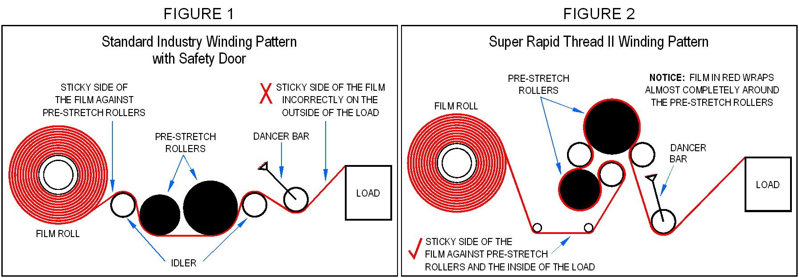

The film carriage is the most critical device on the machine.

The SUPER RAPID THREAD II requires no tuning!!


PRICING SUMMARY:

MODEL | DESCRIPTION | BASE PRICE
7100-65-OHA | Includes 5’ powered infeed, 12’ process, and 5’ outfeed conveyors | $ 53,900

REQUESTED OPTIONS (to be added to the base price of the selected model shown above):

None Requested

TOTAL SYSTEM COST INCLUDING REQUESTED OPTIONS: | $ 53,900

ADDITIONAL AVAILABLE OPTIONS FOR YOUR CONSIDERATION:

A | OCR – Conveyor Ready System” - Remove and delete all three conveyor sections | ($ 6,000)
B | OCDLRCVR5 – Any additional 5’ powered infeed or outfeed conveyor section, per section. | $ 4,290 ea.
C | OSSPK – Starter spare parts kit | $ 1,950

Notes:
- Installation by others
- Factory start-up tech available @ $ 750.00 day plus expenses - billed separately – allow minimum two days.

STANDARD TERMS AND CONDITIONS
TERMS:
- 1/3 down payment with order, balance net 30 days after shipment on approved credit (OAC) - receiving company federal ID#, contact name & phone number required with order.
These terms may change at the discretion of our accounting department.

TAXES:
- Applicable taxes not included.

FOB POINT:
- Factory – Toronto, Ontario (Canada). Freight prepaid and added to invoice.

SHIPMENT:
- Approximately 10 – 12 weeks from receipt of order and down payment (and approved drawings if applicable). Addition of options may add to lead-time.
This lead-time is based on current production conditions and can change without notification.

START-UP SUPERVISION:
- Start-up supervision is highly recommended for in-line conveyorized automatic systems such as the 4100-45-OHA, 6100-CTA & 7100-OHA, and is available for $750 per day plus expenses. Two days on-site are typically sufficient. Weekend start-ups will incur extra charges.

WARRANTY:
- Lifetime on blue pre-stretch rollers, 5 years on metal fabrications and 3 years on buyout components. (see below).

PRICE PROTECTION:
- All prices are valid for thirty (30) days from date of quotation.

STANDARD MACHINE WARRANTY
Effective May, 2011
All components used in the manufacture of pallet wrap equipment and associated parts by Cousins Packaging are warranted to be free from defects in material and workmanship for a period from date of shipment as follows: lifetime on blue pre-stretch rollers, five (5) years for metal fabrications manufactured by Cousins Packaging and three (3) years for buyout components (items purchased by Cousins). Cousins Packaging will, at its sole discretion, repair or replace any defective components.

Not covered by this warranty is normal wear of components such as, but not limited to; belts, chains, fuses, bulbs, etc., or misuse or abuse of the machine or any components thereof. As well, parts returned without the prescribed paperwork will not be covered by this warranty. Labor to remove or repair any component is also not covered by this warranty. Damage in transport is the responsibility of the carrier and is not covered under our warranty.

Except as stated herein, Cousins Packaging makes no other warranty, expressed or implied, nor does it assume or authorize anyone else to assume for it, any other obligation relating to Cousins’ machinery or equipment. This warranty does not apply to equipment that, in the opinion of Cousins Packaging, has been subjected to misuse, neglect, or has been repaired or altered by unauthorized personnel. All defective parts must be returned in their original state. Defective parts that have been disassembled or damaged during removal or otherwise tampered with will not be covered under warranty, unless otherwise stated in writing by Cousins Packaging. Cousins Packaging makes no warranty as to fitness of equipment for particular purposes. Cousins Packaging Inc.’s sole obligation under this warranty will be to provide for repairs to components or replacement of parts, FOB Cousins Packaging Inc., Etobicoke, Ontario, Canada.
of parts, FOB Cousins Packaging Inc., Etobicoke, Ontario, Canada.

